**Hbase Assignment 2**

1. **Access all the tables created in Assignment 1 and run those queries through the python API.**

**Table : 1 Users**

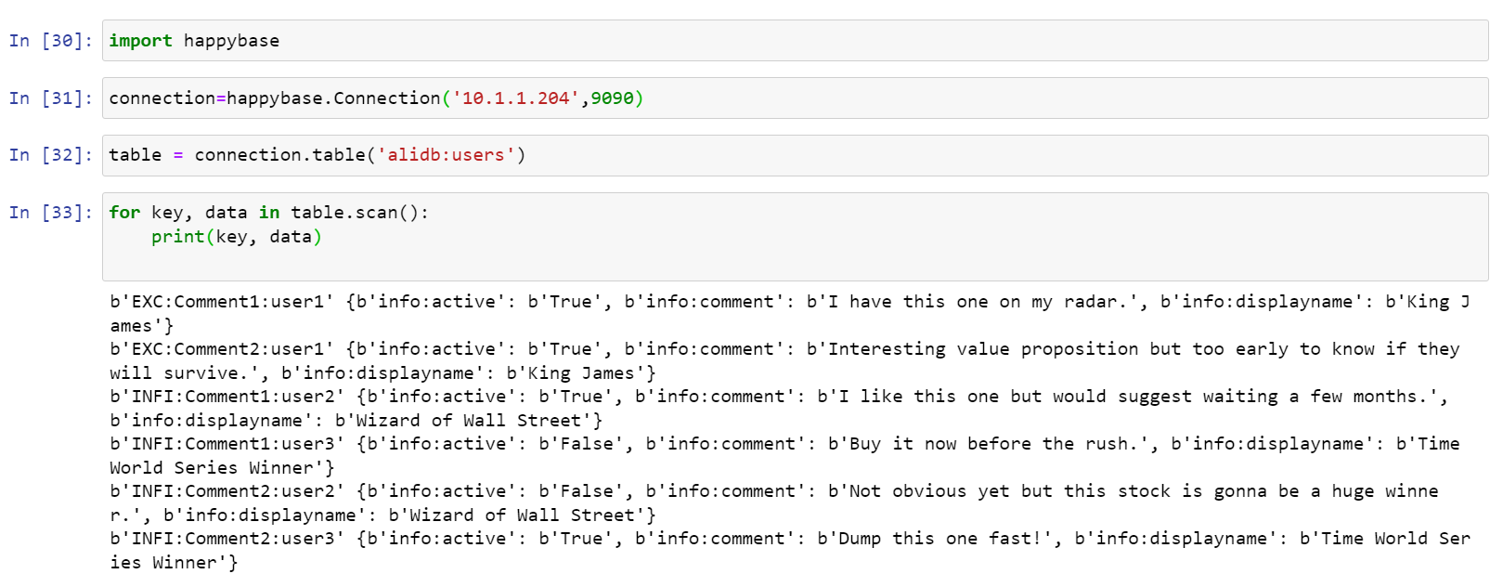

* **What are the various comments given by all the users?**

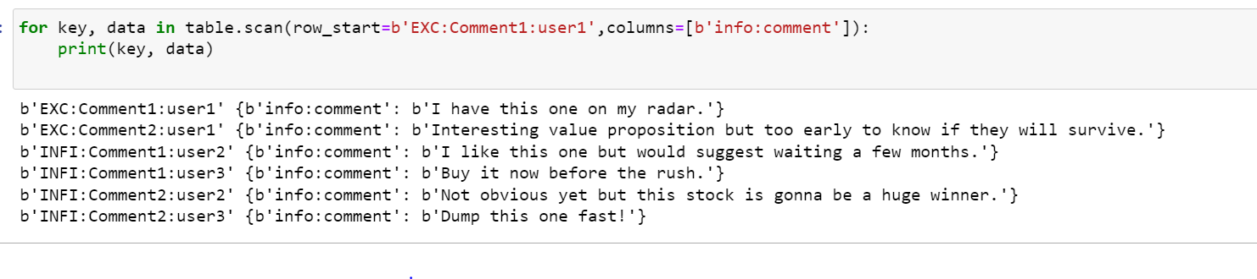

* **What are the comments by user3?**

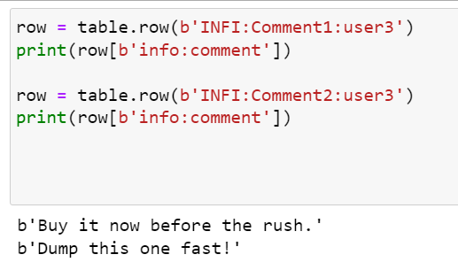

* **Which users have inactive comments?**

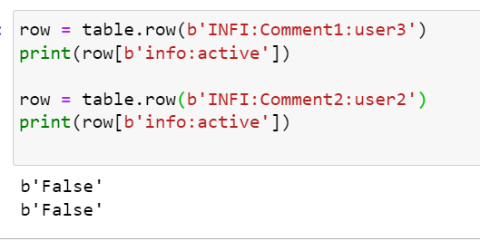

**Table 2 album**

* **Get all songs sung by a singer.**

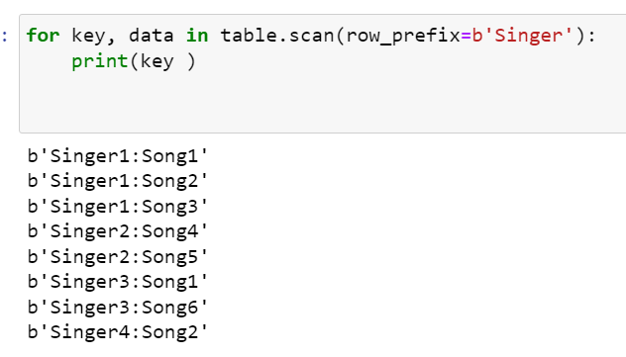

* **Which singer sung for music director AK and what were the songs**

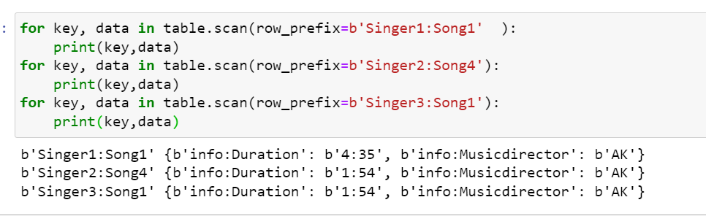

1. Also Create new tables from python and insert some data into those tables.



